OBJECTIVE OF THE EXPERIMENT:
1. To demonstrate the variation of the pressure along a converging-diverging pipe section.
2. The objective is to validate Bernoulli’s assumptions and theorem by experimentally proving that the sum of the terms in the Bernoulli equation along a streamline always remains a constant.
Apparatus Required: Apparatus for the veriﬁcation of Bernoulli’s theorem and measuring tank with stop watch setup for measuring the actual ﬂow rate.
THEORY:
The Bernoulli theorem is an approximate relation between pressure, velocity, and elevation, and is valid in regions of steady, incompressible ﬂow where net frictional forces are negligible. The equation is obtained when the Euler’s equation is integrated along the streamline for a constant density (incompressible) fluid. The constant of integration (called the Bernoulli’s constant) varies from one streamline to another but remains constant along a streamline in steady, frictionless, incompressible flow. Despite its simplicity, it has been proven to be a very powerful tool for ﬂuid mechanics.
Bernoulli’s equation states that the “sum of the kinetic energy (velocity head), the pressure energy (static head) and Potential energy (elevation head) per unit weight of the fluid at any point remains constant” provided the flow is steady, irrotational, and frictionless and the fluid used is incompressible. This is however, on the assumption that energy is neither added to nor taken away by some external agency. The key approximation in the derivation of Bernoulli’s equation is that viscous effects are negligibly small compared to inertial, gravitational, and pressure effects. We can write the theorem as
Pressure head (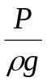)+ Velocity head (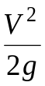)+ Elevation (Z) = a constant
Where, P = the pressure.(N/m²)
r = density of the ﬂuid, kg/m³
V = velocity of ﬂow, (m/s)
g = acceleration due to gravity, m/s²
Z = elevation from datum line, (m)
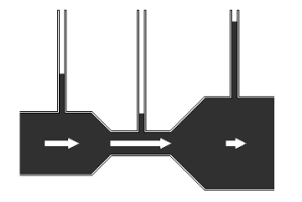
Figure 1.1: Pressure head increases with decrease in velocity head.

P₁/w+V₁²/2g+Z₁= P₂/w+V₂²/2g+Z₂= constant
Where P/w is the pressure head
V/2g is the velocity head
Z is the potential head.
The Bernoulli’s equation forms the basis for solving a wide variety of fluid flow problems such as jets issuing from an orifice, jet trajectory, flow under a gate and over a weir, flow metering by obstruction meters, flow around submerged objects, flows associated with pumps and turbines etc.
The equipment is designed as a self-sufficient unit it has a sump tank, measuring tank and a pump for water circulation as shown in figure1. The apparatus consists of a supply tank, which is connected to flow channel. The channel gradually contracts for a length and then gradually enlarges for the remaining length.
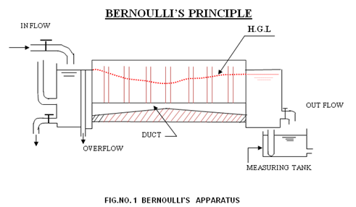
In this equipment the Z is constant and is not taken for calculation.
Procedure:
- Keep the bypass valve open and start the pump and slowly start closing valve.
- The water shall start flowing through the flow channel. The level in the Piezometer tubes shall start rising.
- Open the valve on the delivery tank side and adjust the head in the Piezometer tubes to steady position.
- Measure the heads at all the points and also discharge with help of diversion pan in the measuring tank.
- Varying the discharge and repeat the procedure.
Observations:
Distance between each piezometer = 7.5 cm
Density of water = 0.001 kg/cm³
- Note down the Sl. No’s of Pitot tubes and their cross sectional areas.
- Volume of water collected q = ……………. cm³
- Time taken for collection of water t = …………….sec

OBSERVATION & RESULT TABLE:
Tube No | Area of the flow ‘A’ in (cm²) | Discharge ‘Q’ in (cm³/sec) | Velocity ‘V’ in (cm/sec) | Velocity head in (cm) | Pressure head in (cm) | Total head  ‘H’ (cm)
1
2
3
4
5
6
7
8
9
10
11

Sample Calculations:
1. Discharge Q = q / t =………….. cm³/sec
2. Velocity V= Q/ A= ................... = ………. cm/sec
Where A is the cross sectional area of the fluid flow
3. Velocity head V²/2g = ………….. cm
4. Pressure head (actual measurement or piezometer tube reading)

P/w= ……………… cm

5. Total Head
H = Pressure head + Velocity Head = ………...........…….. cm

Result & Discussion:
- Plot the graph between P/w and x.
- Plot the graph between V²/2g and x.

QUIZ:
  - Bernoulli’s equation holds good for non ideal fluids
    - True
    - False
  - The pressure head is given by
    - P/γ
    - V²/2g
  - Bernoulli’s theorem deals with law conservation of momentum
    - True
    - false
- What is piezometer tube?
REFERENCES:
- Fluid mechanics - Dr.R.K.Bansal
- Experiments in fluid mechanics - Sarabjit Singh
- Wikipedia

PART – 2
ANIMATION STEPS
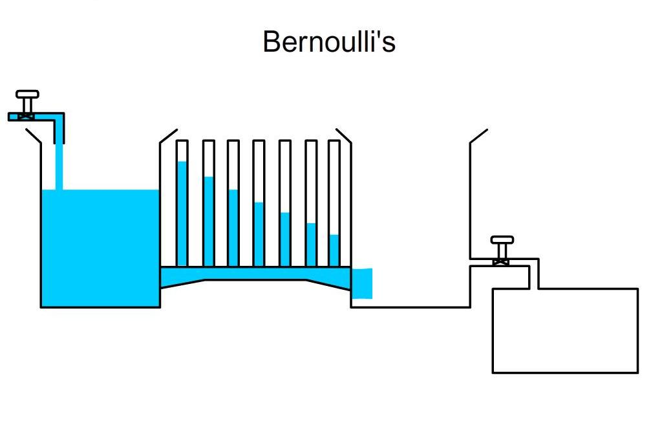

PART – 3
VIRTUAL LAB FRAME

